**Assigment#1**

**Isma Kanwal**

**20-Arid-770**

**Question#**

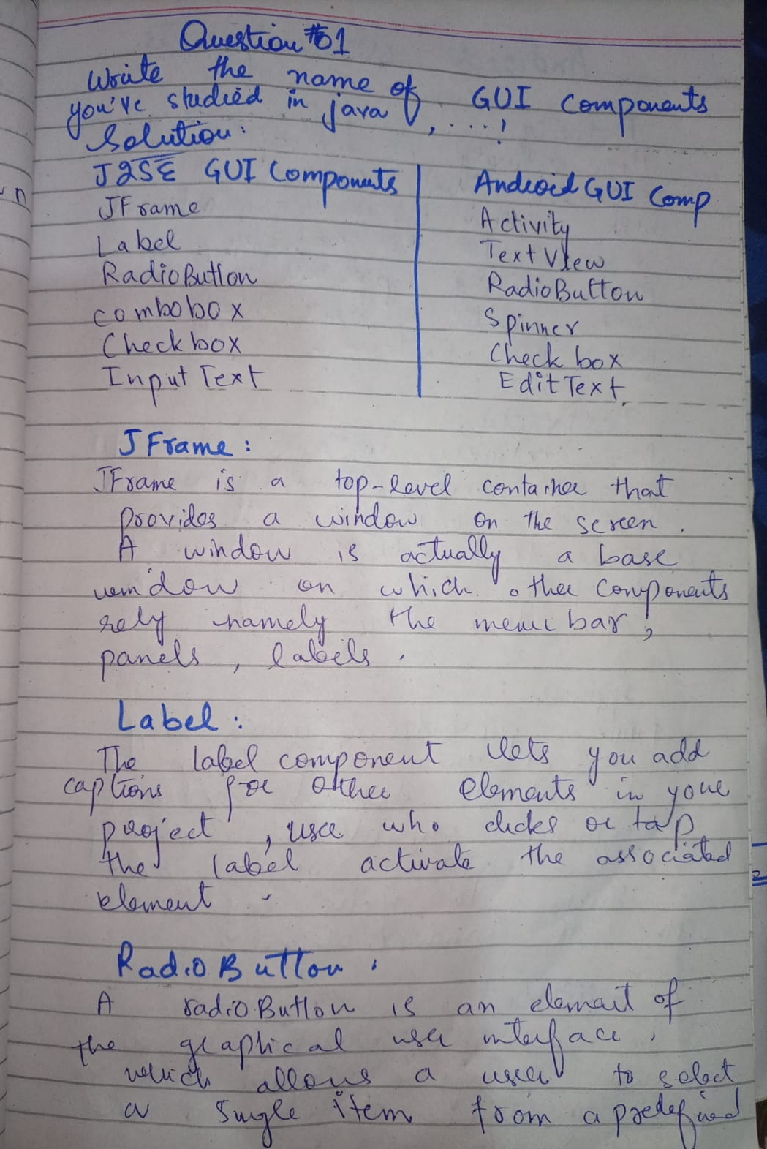

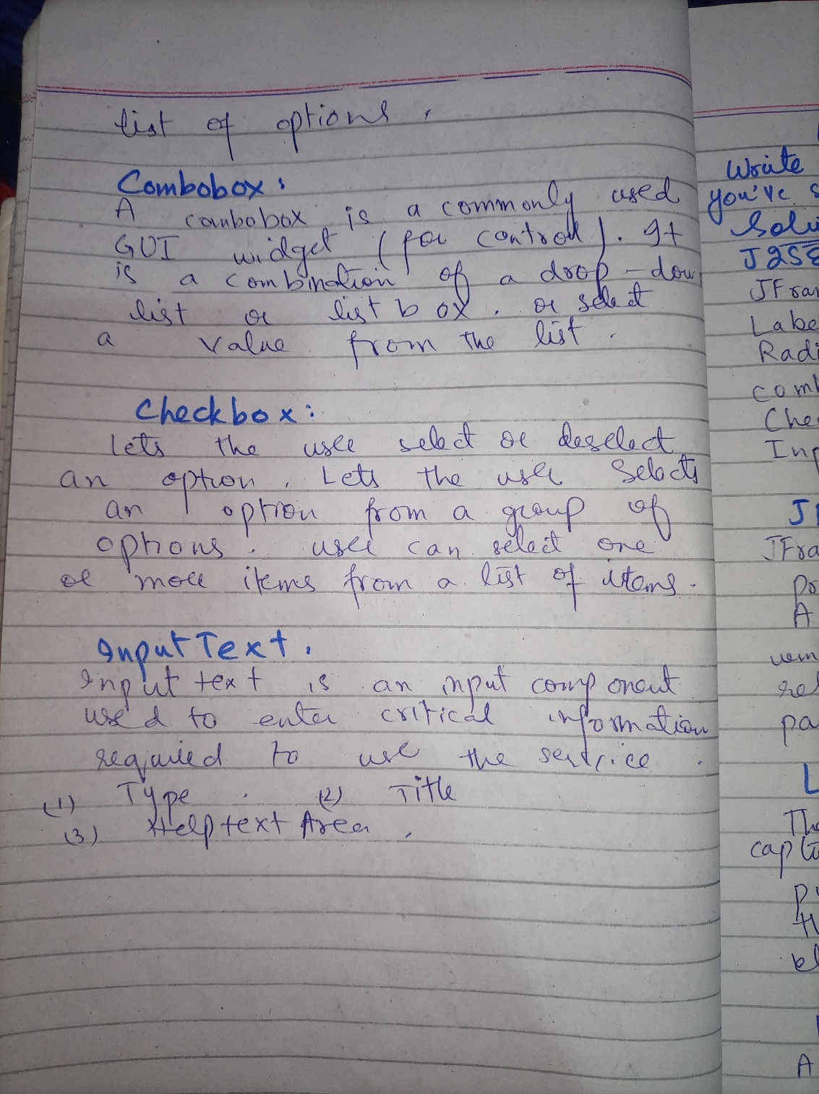

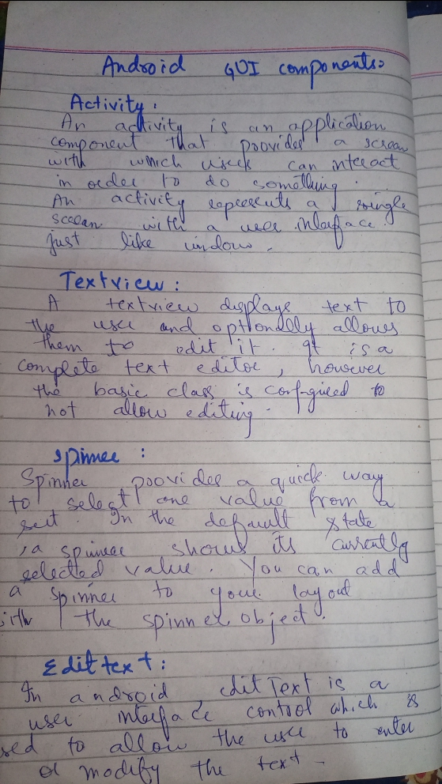

**Question#2**

**Group members:**

* **Komal ayub**
* **Rabbia Faiz**
* **Isma kanwal**

<?xml version="1.0" encoding="utf-8"?>  
<androidx.constraintlayout.widget.ConstraintLayout xmlns:android="http://schemas.android.com/apk/res/android"  
 xmlns:app="http://schemas.android.com/apk/res-auto"  
 xmlns:tools="http://schemas.android.com/tools"  
 android:layout_width="match_parent"  
 android:layout_height="match_parent"  
 tools:context=".MainActivity">  
  
 <Button  
 android:id="@+id/button11"  
 android:layout_width="wrap_content"  
 android:layout_height="wrap_content"  
 android:layout_marginBottom="28dp"  
 android:text="Start Quiz"  
 app:iconTint="@color/material_dynamic_primary80"  
 app:layout_constraintBottom_toTopOf="@+id/button12"  
 app:layout_constraintEnd_toEndOf="parent"  
 app:layout_constraintHorizontal_bias="0.498"  
 app:layout_constraintStart_toStartOf="parent" />  
  
 <Button  
 android:id="@+id/button12"  
 android:layout_width="wrap_content"  
 android:layout_height="wrap_content"  
 android:layout_marginBottom="64dp"  
 android:text="Book Mark"  
 app:layout_constraintBottom_toBottomOf="parent"  
 app:layout_constraintEnd_toEndOf="parent"  
 app:layout_constraintStart_toStartOf="parent"/>  
  
 <FrameLayout  
 android:layout_width="418dp"  
 android:layout_height="444dp"  
 android:background="@color/purple_200"  
 app:layout_constraintEnd_toEndOf="parent"  
 app:layout_constraintHorizontal_bias="0.0"  
 app:layout_constraintStart_toStartOf="parent"  
 app:layout_constraintTop_toTopOf="parent">  
  
 <TextView  
 android:id="@+id/textView2"  
 android:layout_width="329dp"  
 android:layout_height="144dp"  
 android:layout_gravity="center"  
 android:text="Quiz Application "  
 android:textSize="42dp"  
 android:textStyle="bold" />  
 </FrameLayout>  
  
</androidx.constraintlayout.widget.ConstraintLayout>

